Week of February 24 - 28
Mrs.. BEntleys Classroom News
Important Dates To Remember…
Feb 25 VIP envelopes come home
Mar 10 VIP envelopes come home
Mar 13 Teacher Workday
Mar 24 Teacher Workday
Apr 6 – 15 Spring Break

Other Class News…
Our students have been earning Stinky Feet (take shoes off) , Show and Tell,band Fluffy Friend passes for their great behavior! If you see these come home they may bring them in on a day of their choice! They need to return the white card back to Mrs. Bentley.

English | Math | Science | Social Studies
Skills:  Reading: Context clues  Language Arts: Reflexive Pronouns  Writing: Informational Writing- Country Research | Applying Base Ten Understanding  On:  -Inverse Operations  - Word Problems  ACC:  -Fractions | None | Civil Rights &  Human Rights  -Jackie Robinson  -Dr. Martin Luther King, Jr.  - Juliette Gordon Low  -Jimmy Carter  *Review study Guide  *Test – Friday 2/28  Study Guide going home Monday 2/24

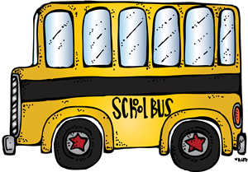

Mrs..Bentley’’s class
Week of February 24 - 28

Mon | Tue | Wed | Thu | Fri
24 | 25 | 26 | 27 | 28
On and ACC: Math Facts 20m  Read 20 minutes | On and ACC: Math Pages  20m | On and ACC: Iready Math 20m  Read 20 minutes | On and ACC: Math Pages  Read 20 minutes | Turn in Homework

